EASTERN INTERNATIONAL UNIVERSITY | Practice Assignment – Quarter 4, 2025- 2026
SCHOOL OF COMPUTING  AND INFORMATION TECHNOLOGY | Course Name: ISAD  Course Code: CSW 309
Student’s Full Name: Vũ Đức Tùng
Student ID: 2331200132

LAB 03
Level-0 DFD & Concept ERD

- Objectives
After completing this session, students will be able to:
- Derive Level-0 DFD processes from main functional requirements and use cases.
- Identify external entities, processes, data stores and data flows.
- Identify entities, attributes, identifiers, relationships and cardinalities for a Concept ERD.
- Check consistency among requirements, use cases, Level-0 DFD and Concept ERD
- Scenario: Student Service Request Processing
Students submit requests for academic documents. Each request has a request number, request type, submitted date, status, student information, required details and optional supporting documents. Staff review each request, check whether the information is complete and either ask the student for additional information, approve the request, reject the request or mark the request as completed. The system keeps request history and sends notifications to students when the status changes. Managers need summary data about request volume, status and processing time.
The system stores student accounts, request types, service requests, uploaded documents, staff accounts, request status updates and notifications. Students can view only their own requests. Staff can view requests assigned to their unit. Managers can view summary information but do not process individual requests.
- Requirements
Complete the following tasks. This lab focuses only on Level-0 DFD and Concept ERD.
  - Problem Description and System Request
- Summarize the problem (why the system is needed).
+ Currently, the management of student academic documents request lacks a centralized system, making it difficult for students to track the status of their request. Staff members struggle to efficiently review files and manage workflows and manager lack an easy way to access summary data regarding request volume and processing times.
  - Write the goal
+ To develop a Student Service Request Processing system that allows students to submit and check their request status, enable staff to review and process requests efficiently, and provides managers with analytical sumary data.
  - Write 2–3 expected benefits
+ It make the process clearly by sending automatic messages to students when their request changes.
+ It help staff work better because they can easily find and update the requests for their own department.
+ It give managers useful reports about the number of requests and processing times so they can make good decisions.
  - Functional Requirements
List at least 05 main functional requirements of the system
  - System will allow students send requets for academic documents and add extra supporting files if they need to.
  - System will allow students to see the history and current situation of their own requests
  - System shall allow staff to look at requests, ask for more information, accept, refuse or finish them.
  - The system shall automatically send a message to student when the status of their request changes.
  - The system shall allow managers to look at summary information about how many request there are, their status and the time it take to finish them.
  - Level-0 DFD
    - Prepare process list for Level-0 DFD
Identify 4-6 major processes. Use verb-noun names and avoid very detailed screen-level steps.
Process No. | Process Name
1.0 | Submit service request
2.0 | Process service request
3.0 | Manage notifications
4.0 | Generate summary reports
    - Identify DFD elements
List external entities, data stores and major data flows before drawing the diagram.
Element Type | Name | Description / Data Content
External Entity | Student | Sends requests and gets messages about their status
External Entity | Staff | Checks requests and changes the status for their department.
External Entity | Manager | Looks at summary data about the number of requests and time.
Data Store | D1: Student Accounts | Keeps student personal information and logins.
Data Store | D2: Staff Accounts | Keeps staff information and their work unit.
Data Store | D3: Service Requests | Keeps request numbers, types, dates, statuses, and uploaded files.
Data Store | D4: Notifications | Keeps a record of status changes and messages sent.
Data Flow | Request Details | The form information and extra files given by the student.
Data Flow | Status Update | The choice (accept/refuse/ask for info) made by the staff member.
Data Flow | Summary Data | Combined information about work amount and time.
    - Draw Level-0 DFD
- Draw one Level-0 DFD for the system.
- Include external entities, major processes, data stores and data flows.
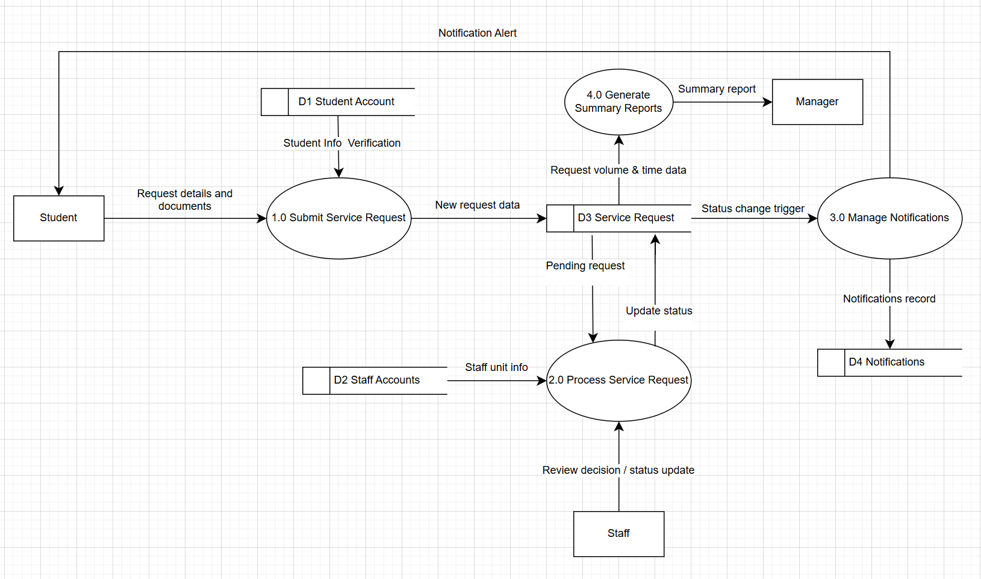

  - Concept ERD
    - Identify Concept ERD components
Identify candidate entities, attributes and identifiers
Entity | Key Attributes | Other Attributes | Reason from Scenario
Student | studentId | name, email | The system needs to keep student accounts so they can see only their own requests.
Staff | staffId | name, unit | The system keeps staff accounts so they can only see requests for their own unit.
ServiceRequest | requestNumber | requestType, submittedDate, status, requiredDetails | The system must keep the details, status updates, and files of each request.
Notification | notificationId | message, sendDate | The system saves a history of status changes and messages given to students
    - Define relationships and cardinalities
Define the main relationships between entities and state cardinalities/business rules.
Relationship | Cardinality | Business Rule
Student – submits - ServiceRequest | 1 : N | One student can send many requests, but each request belongs to exactly one student.
Staff – processes – ServiceRequest | 1 : N | One staff member can handle many requests, but each request is given to one staff member.
ServiceRequest – triggers - Notification | 1 : N | One request can create many notifications when its status changes over time.
    - Draw Concept ERD
- Draw a Concept ERD using correct notation.
- Show entities, identifiers, relationships and cardinalities.
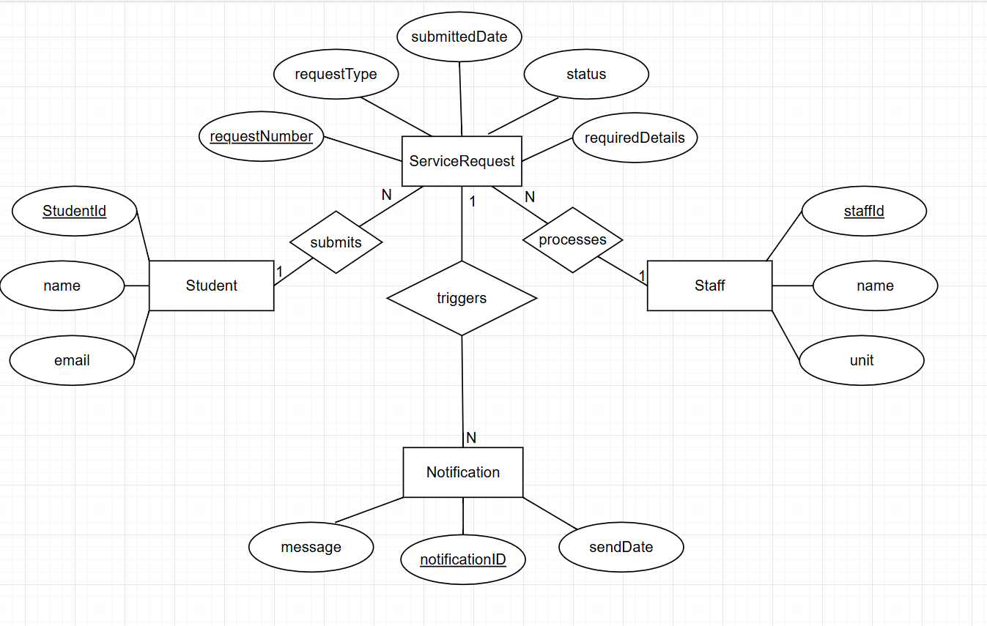
- Assessment
Task # | Criteria | Points
1 | Problem Description and System Request | 10
2 | Functional Requirements | 10
3 | DFD major process identification | 10
4 | DFD element identification | 10
5 | Level-0 DFD | 20
6 | ERD elements | 10
7 | ERD relationship and cardinalities | 10
8 | Concept ERD | 20
- Submission
Submit one PDF report and editable diagram file(s). File name format: CSW309_Lab03_StudentNo_StudentName

